**A PROPOSED OFFERING OF A GYM MANAGEMENT**

**SYSTEM FOR ANYTIME FITNESS GYM**

A Design Document Presented to the

Faculty of Datamex College of Saint Adeline, Inc.

In Partial Fulfillment of the Requirements for the

Degree of Bachelor of Science in Information Technology

By:

Revilla, James Andrei N.

**INTRODUCTION**

This document serves as a comprehensive design specification for the Gym Management System (GMS), created to streamline the operational activities of Anytime Fitness Gym. The system automates and secures routine workflows such as staff authentication, member registration and management, attendance tracking, equipment inventory management, payment processing, and administrative reporting. By digitizing these processes, the GMS aims to enhance operational efficiency, reduce human error, and improve overall gym management.

The GMS is realized as a Windows desktop application developed in Visual Basic 2010 (VB.NET) that interfaces directly with a MySQL database managed through the XAMPP environment. The design consolidates multiple operational facets into a unified platform, incorporating secure password hashing and two-factor authentication to restrict system access to authorized personnel only. Comprehensive management of member data, equipment records, attendance logs, and financial transactions are centralized within a carefully normalized database schema to ensure integrity and scalability.

This design document covers all aspects of the system’s architecture, user interface design, component specifications, data models, security considerations, performance objectives, error management strategies, deployment planning, and maintenance guidelines. It is intended as a detailed reference for developers, system administrators, testers, and future maintenance teams.

**SYSTEM ARCHITECHTURE**

The Gym Management System employs a monolithic client-server architecture. The desktop application written in Visual Basic 2010 encompasses presentation and business logic layers while communicating directly with a MySQL database backend via ADO.NET. The absence of intermediate web APIs simplifies the architecture and facilitates direct, performant communication between the client and the data repository.

The architecture distinctly separates concerns into three layers:

* The Presentation Layer provides intuitive user forms for staff interaction, including login, dashboards, data entry, editing, and reporting.
* The Business Logic Layer encapsulates validation rules, workflows, membership status determinations, payment processing, and analytical computations.
* The Data Access Layer handles all interactions with the MySQL database, executing parameterized SQL queries and managing transactions to maintain data consistency.

**High-Level Components and their Interactions**

Core system modules include Authentication, Member Management, Equipment Management, Attendance Tracking, Payment Handling, Dashboard Reporting, and Staff Account Administration. Each module interacts cohesively within the application to provide seamless workflows. For instance, the process of adding a new member combines data validation, payment confirmation, database insertion, and immediate dashboard update.

**Deployment Architecture**

Deployment is realized on Windows client machines where the VB.NET application runs locally, connecting over a secure TCP/IP channel to the MySQL database hosted on a local or networked server under the XAMPP stack. Network access is protected by firewalls and optionally VPNs to safeguard against unauthorized external access.

**Communication Protocols and Interfaces**

Communication between the client and database employs MySQL’s native protocol over port 3306. Security is enforced through encrypted password storage, two-factor authentication leveraging stored security questions, and parameterized queries that mitigate risks of SQL injection attacks.

Advanced features such as connection pooling enable efficient handling of multiple database operations, improving scalability. Error handling is integrated at both code and interface layers to ensure robust system stability and user guidance in case of failures.

**DATABASE DESIGN**

The Gym Management System is supported by a relational database structured to store and manage critical data related to users, members, gym equipment, attendance records, and payment transactions. The ERD graphically depicts entities as tables, their primary keys, attributes, and relationships, ensuring a clear understanding of data flow and dependencies.

Core entities include:

* **Staff Accounts**: Stores staff and administrative account information including unique identifiers, hashed passwords, security questions and answers, two-factor codes, and account status to control access privileges.
* **Membership Plans:** Defines predefined subscription options such as monthly, quarterly, semi-annual, and annual packages with set durations and prices.
* Add-On Services: Contains optional services like personal training, nutrition coaching, and locker rental, with billing types based on per-session or monthly charges.
* **Members:** Consolidates personal information, chosen membership plan, billing frequency, status flags (active, expired), and registration details.
* **Member Add-Ons**: Manages the many-to-many relationship between members and optional services, including service quantities purchased.
* **Payments:** Records all financial transactions including downpayments, balances, and add-on purchases, ensuring proper tracking of member financial activity.
* **Gym Equipment:** Maintains detailed records of gym assets, including equipment names, categories, purchase dates, and condition statuses for maintenance management.
* **Attendance:** Tracks member check-ins and check-outs to monitor engagement and usage patterns.

The schema adheres to third normal form eliminating redundancy by ensuring each non-key attribute depends solely on the primary key in its table. Transaction management within the database supports atomicity, ensuring critical operations involving multiple updates (such as adding members and recording payments) succeed or fail entirely, maintaining consistent states.

**Description of Database Tables, Fields, and Relationships**

The database consists of several interrelated tables that organize information about staff accounts, membership plans, optional services, members, payments, equipment, and attendance. Each table has a primary key to uniquely identify records and uses foreign keys to establish relationships, ensuring data consistency and integrity across the system.

* + **StaffAccounts Table**  
     Fields include StaffID (PK), username, password hash, security question and answer hash, account status, two-factor code, and date created. This table manages staff and administrator accounts, handling authentication and access control within the system.
  + **MembershipPlans Table**  
     Fields include PlanID (PK), plan name, duration in months, and price. This table defines the available membership packages such as monthly, quarterly, semi-annual, and annual plans, which members can select upon registration.
  + **AddOnServices Table**  
     Fields include AddOnID (PK), service name, price, and billing type. This table specifies optional services like personal training, nutrition coaching, and locker rentals, including their corresponding pricing and billing structure.
  + **Members Table**  
     Fields include MemberID (PK), full name, email, contact number, emergency contact, birthdate, address, date of registration, plan ID (FK), billing frequency, and status. This table stores member details and links them to their chosen membership plan through the PlanID foreign key.
  + **MemberAddOns Table**  
     Fields include MemberAddOnID (PK), member ID (FK), add-on ID (FK), and quantity. This table manages the many-to-many relationship between members and add-on services, recording which services are availed and in what quantity.
  + **Payments Table**  
     Fields include PaymentID (PK), member ID (FK), amount, payment date, and payment type. This table tracks all financial transactions including downpayments, balances, and add-on purchases made by members.
  + **GymEquipment Table**  
     Fields include EquipmentID (PK), equipment name, category, purchase date, and condition status. This table maintains the inventory of gym equipment and supports monitoring of usage and maintenance needs.
  + **Attendance Table**  
     Fields include AttendanceID (PK), member ID (FK), check-in time, and check-out time. This table records member attendance by tracking entry and exit times linked to each member.

**Relationships Summary**  
 The Members table connects directly to the MembershipPlans table through PlanID, ensuring each member is linked to a subscription plan. Members are also associated with Payments and Attendance through their MemberID, allowing the system to track both financial transactions and gym usage. The MemberAddOns table establishes a many-to-many relationship between Members and AddOnServices, recording which services are subscribed by which member. Together, these relationships integrate member information with plans, services, financial records, and attendance to provide a complete management system.

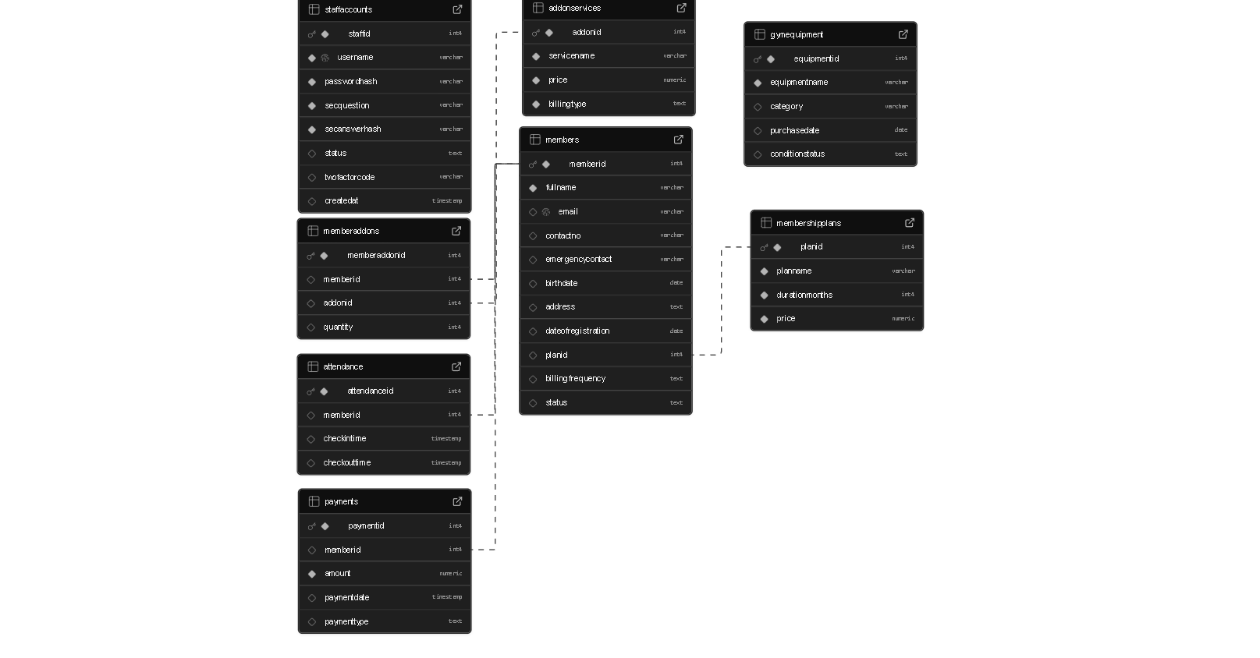

**Figure 1.** Database Schema

**USER INTERFACE DESIGN**

The User Interface (UI) of the Gym Management System is designed to provide a simple, user-friendly, and efficient experience for both staff and members. It organizes system functionalities into clear modules such as staff login, member registration, plan selection, add-on management, payment processing, equipment monitoring, and attendance tracking. Each interface is structured with intuitive navigation, labeled input fields, and clear feedback messages to minimize user errors and improve usability. The design emphasizes accessibility, ensuring that both staff and administrators can easily perform their tasks while maintaining smooth interaction with the database.

**Loading Screen**

This is the loading screen that will first to see before the login forms shows the purpose of a loading screen is to inform users that a process is underway and the system is working, helping to manage expectations and improve perceived performance.

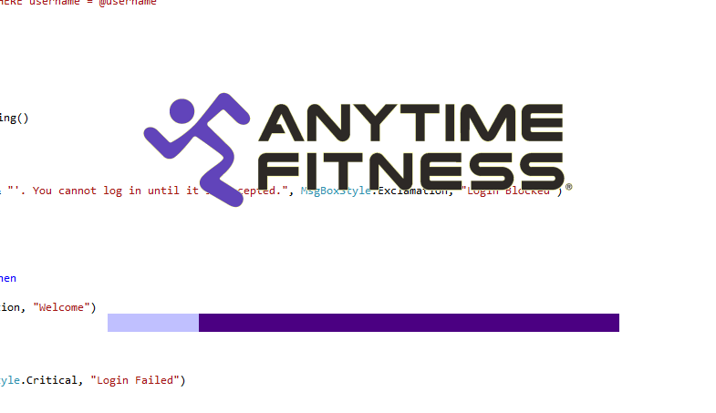

**Figure 2.** Loading Form

**Login Form**

Here in the login form where the user’s login their account that they created in register form after that it will direct in the dashboard form

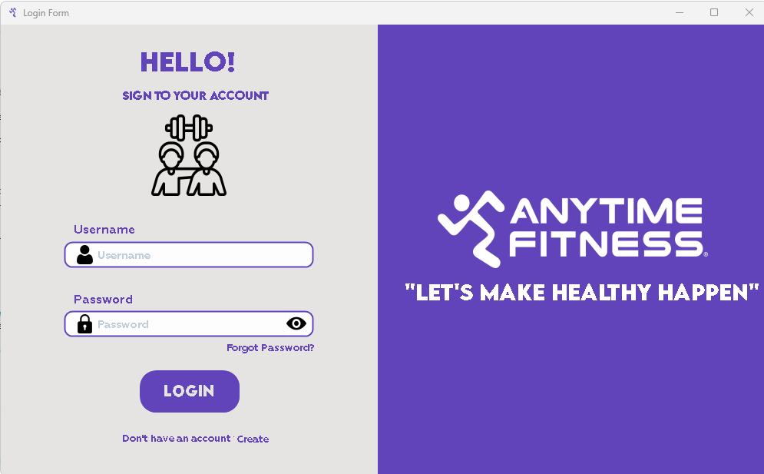

**Figure 3.** Login Form

**Register Form**

In this form the user will register to create their new account that will be registered to login their account.

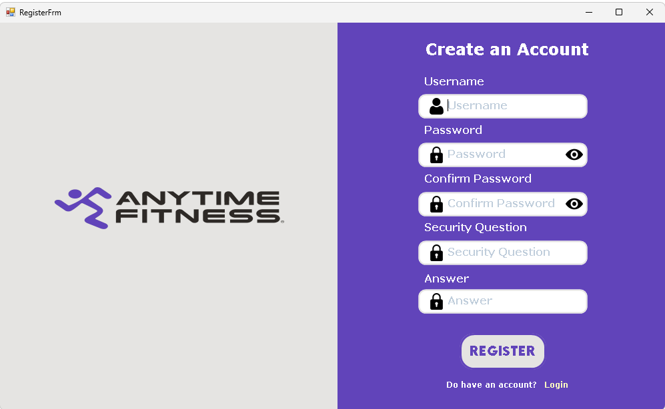

**Figure 4.** Register Form

**Dashboard Form**

This form shows all the statistics in the system like the whole member, active members gym equipment’s etc.

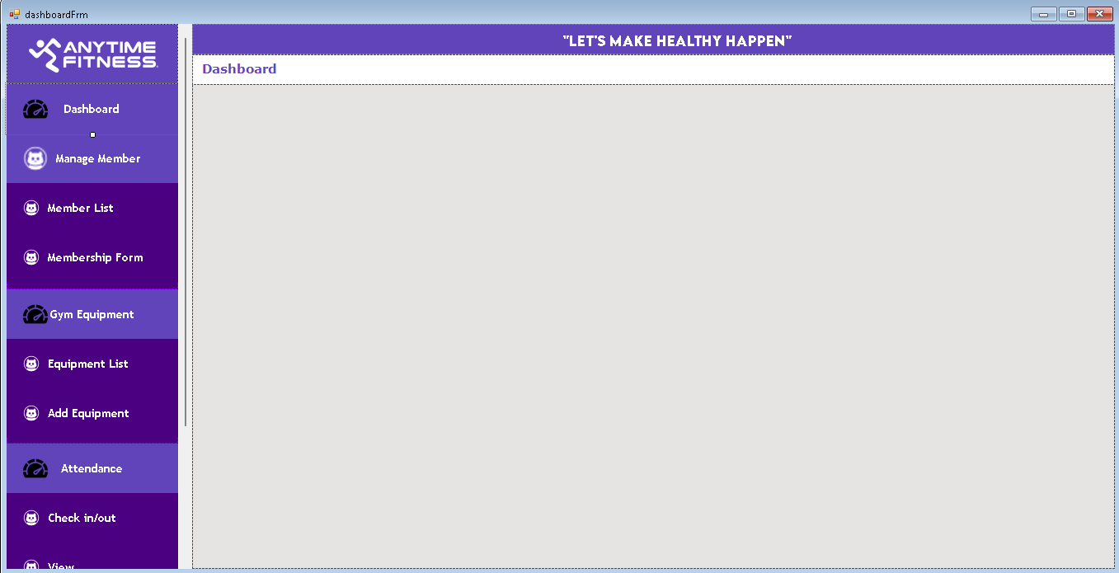

**Form 5.** Dashboard Form

**Manage Member – Student List**

In this form you can see all the member list that the system database have you can all search edit member and delete member in this form

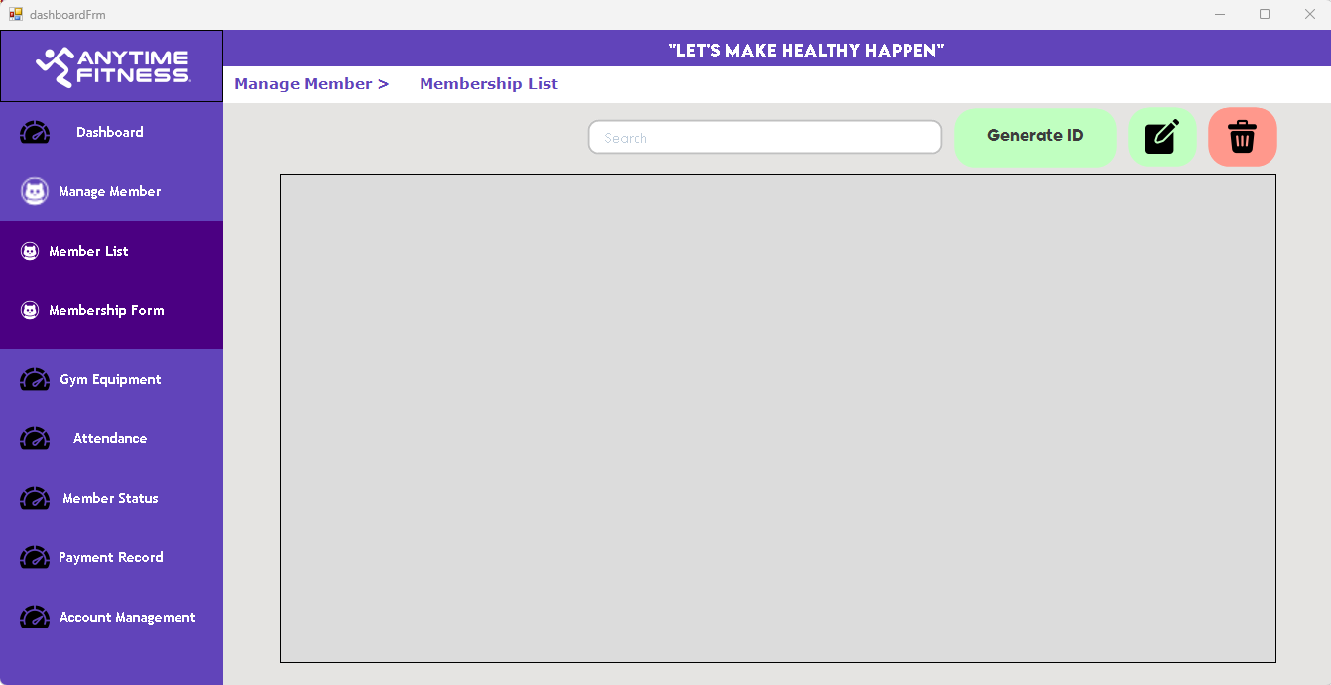

**Figure 6.** Member List

**Manage Member – Add Student**

In this form where you can add member and add a payment to be a member

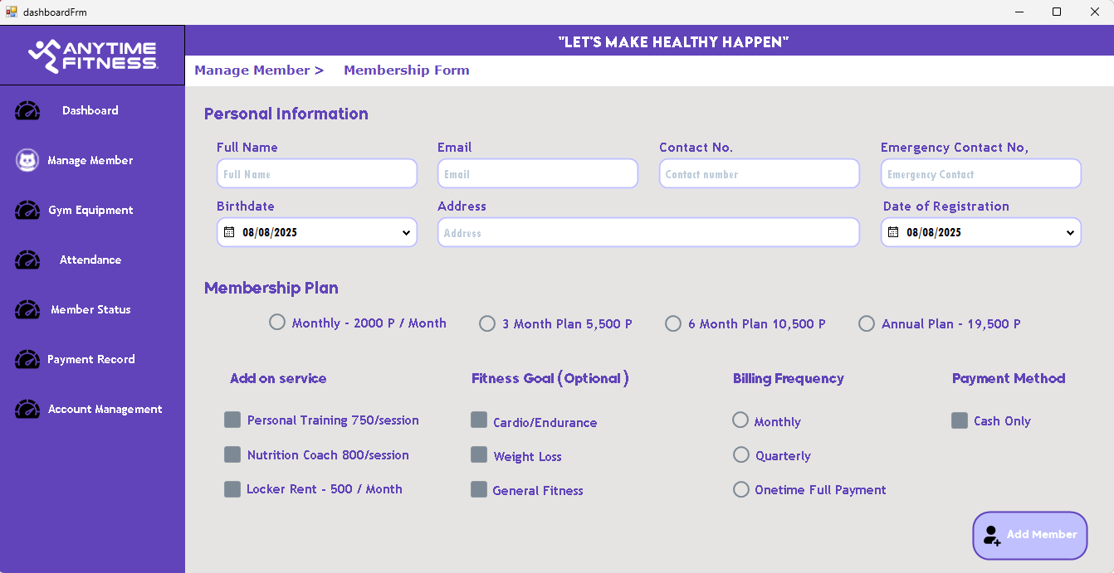

**Figure 7.** Add Member

**Gym Equipment – Gym Equipment List**

In this form you can see all the equipment list that the system database have you can all search edit equipment and delete equipment in this form

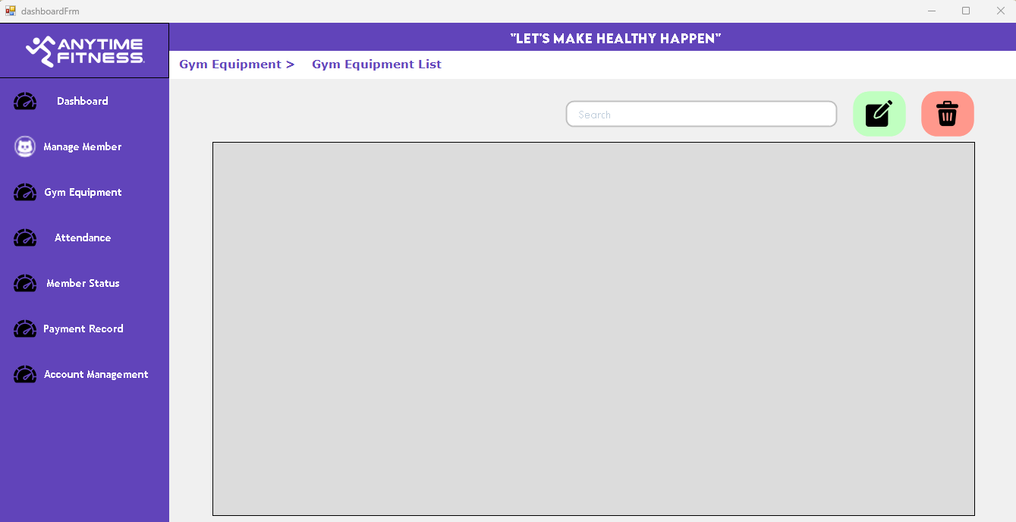

**Figure 8.** Equipment List

**Manage Member – Add Equipment**

In this form where you can add equipment

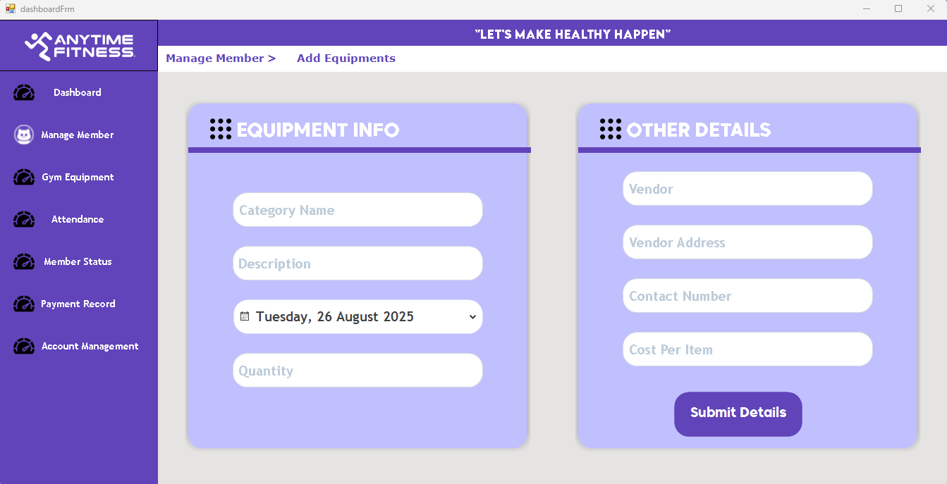

**Figure 9.** Add Gym Equipment

**Attendance – Check IN /OUT**

In this form is where you can track whether the member is in the gym or not



**Figure 10.** Check In / Out Member

**Attendance – Attendance Record**

In this form where all the count of attendance of member has been count

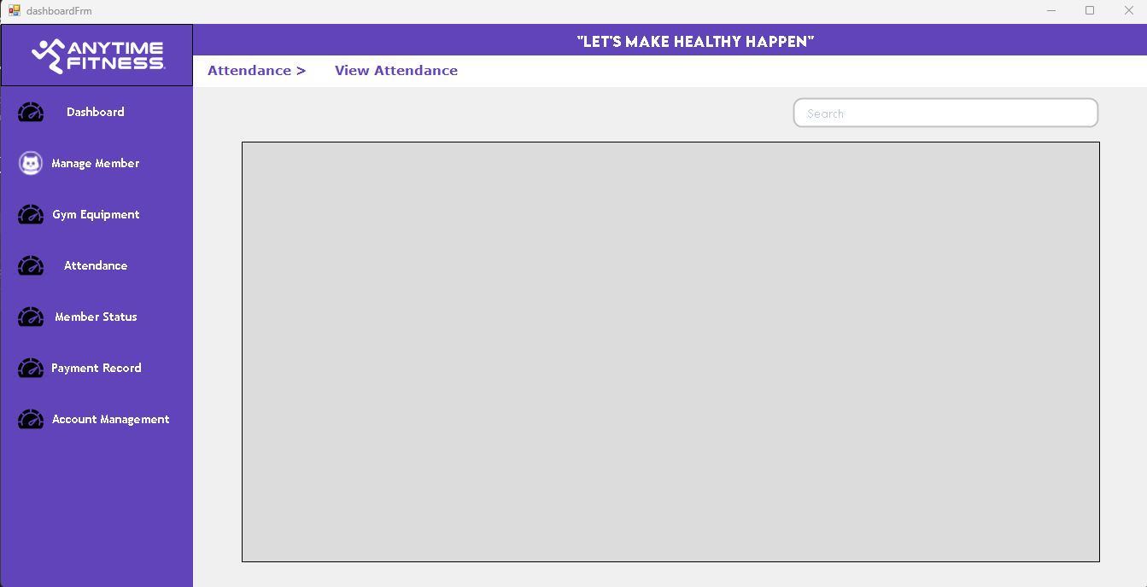

**Figure 11. Attendance Record**

**Member Status**

In this form is where you can see if the member is active or not

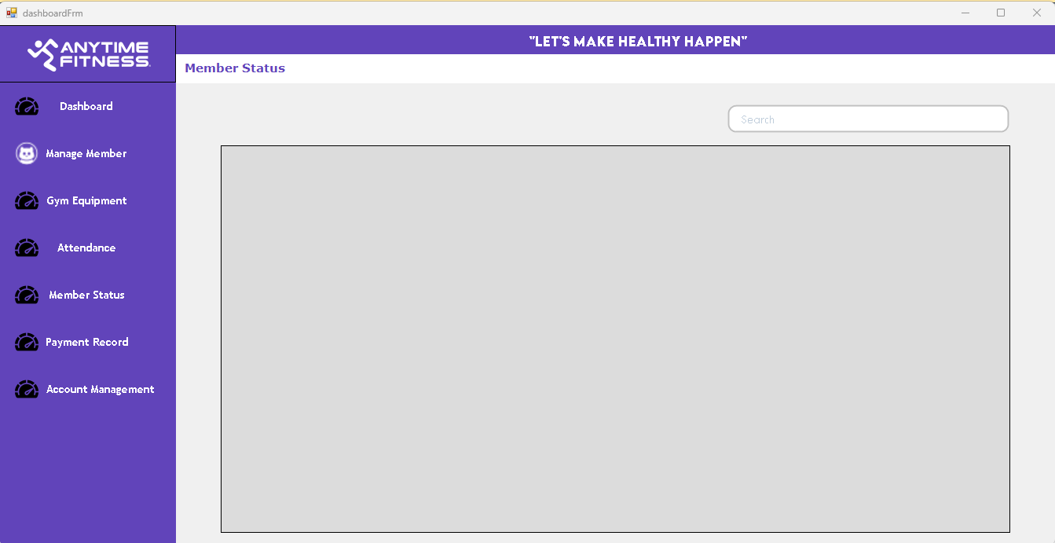

**Figure 12.** Member Status

**Payment Record**

In this form where you can see all the payments record of the members

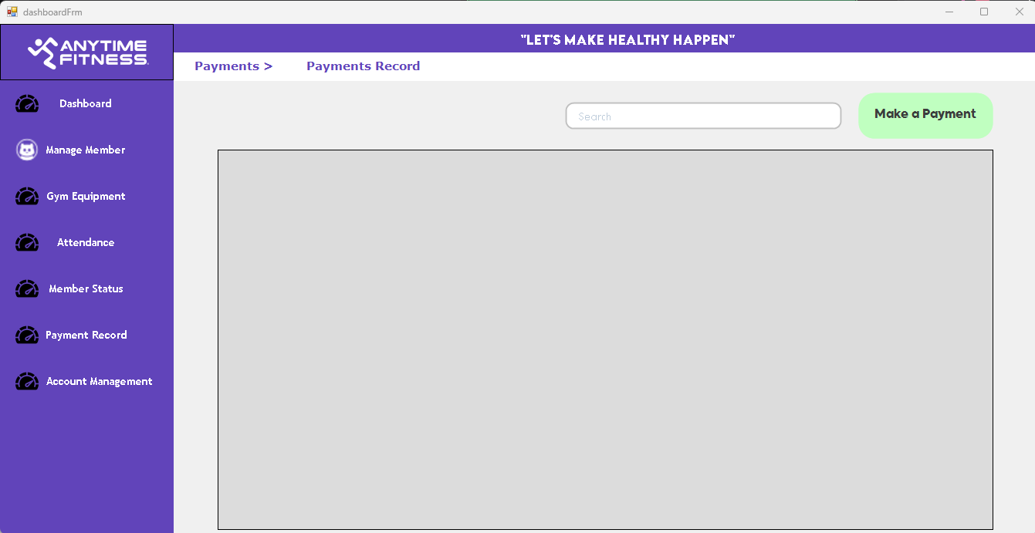

**Figure 13. Payment Record**

**Manage Account**

In this form is where you can manage account if you want to accept it

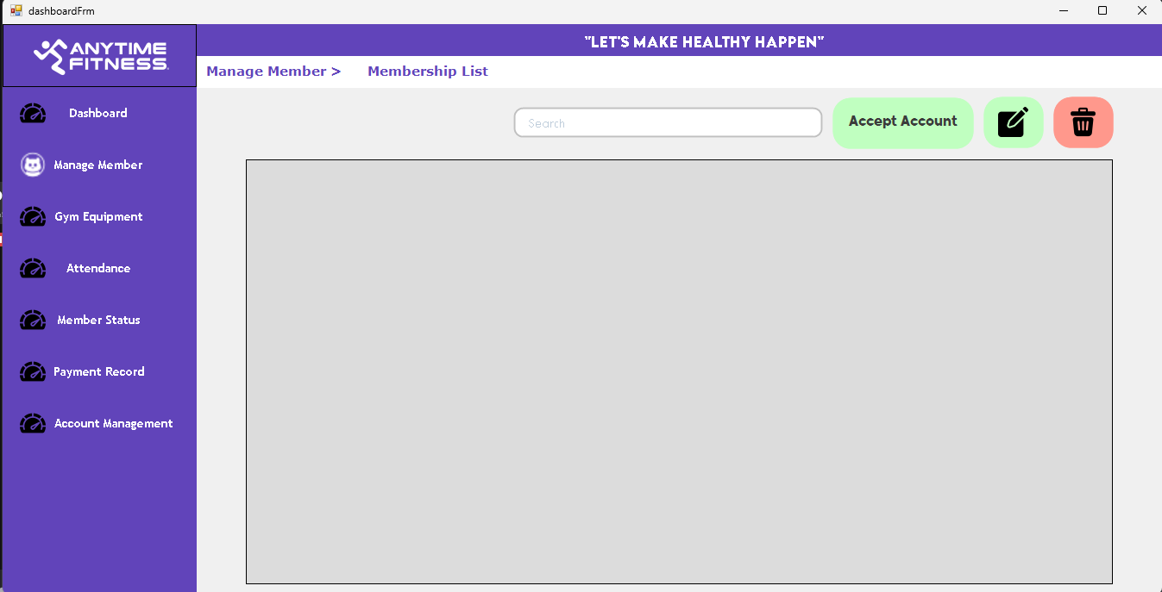

**Figure 14.** Manage Account

**ID Form**

In this form where you can see the membership Card ID

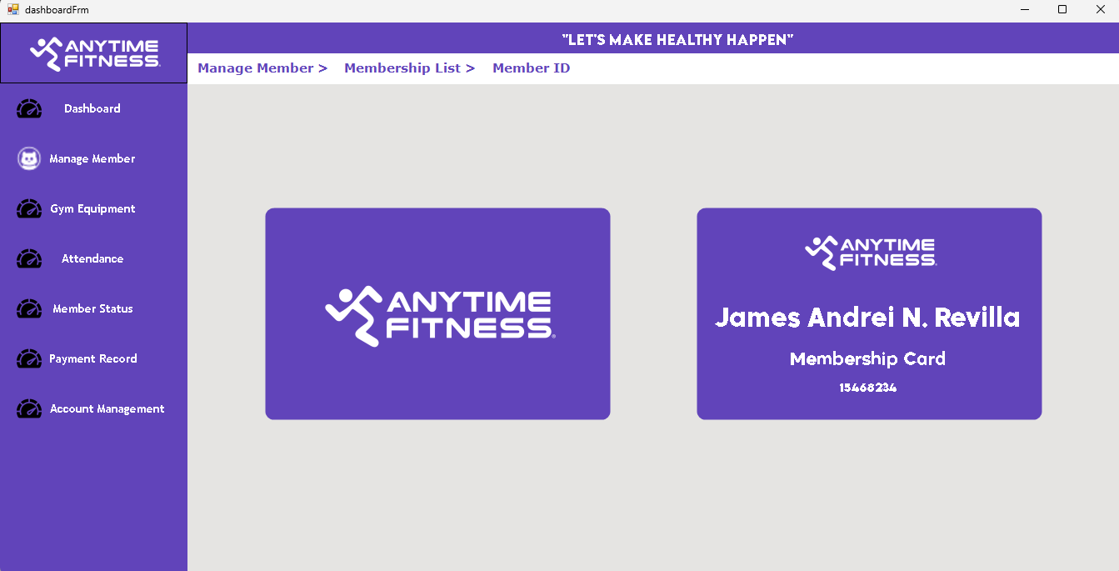

**Figure 15. Member ID**

**COMPONENT DESIGN**

The Gym Management System is composed of a set of tightly integrated components developed entirely within the Visual Basic 2010 Windows Forms application. This monolithic design encapsulates all business logic, database connectivity, UI interaction, and workflow management without external API calls or third-party service dependencies. Each module is responsible for specific functionalities, ensuring maintainability and clarity in the system’s organization.

**Authentication Module**

This module manages staff user login, registration, and security by performing password verification with securely hashed credentials and two-factor authentication via stored security questions and hashed answers. It also implements password recovery workflows and handles session management within the application to prevent unauthorized access.

**Member Management Module**

Responsible for creating, reading, updating, and deleting member information. It performs input validation, enforces business rules such as requiring a down payment before membership activation, and generates unique membership IDs. All database interactions are performed with carefully parameterized SQL commands through VB.NET’s ADO.NET to maintain security.

**Equipment Management Module**

Facilitates inventory control of gym equipment. Staff can add new equipment records, modify existing items, and delete obsolete records. This module handles validation of entries such as quantity and purchase dates, and maintains vendor contact information for procurement or maintenance.

**Attendance Module**

Enables staff to record member check-ins and check-outs by updating attendance logs with timestamps. This module prevents duplicate check-ins for the same session and accurately tracks total attendance count per member. It also supports searching and viewing attendance records within specified date ranges.

**Payment Processing Module**

Handles all monetary transactions related to member account balances. Staff enter payment details which update the member's outstanding balances and trigger membership status changes based on payment completion. The module supports partial payments and maintains a full history of payment transactions for auditing and reporting.

**Dashboard Module**

Aggregates data from various modules to provide real-time summary statistics on members, equipment, attendance, and payments. It renders charts and tabular data to assist administrative decision-making. This module optimizes data queries and caches frequently requested statistical data to improve performance.

**Account Management Module**

Allows administrators to manage staff accounts, including creating new accounts, modifying access privileges, suspending, or deleting users. It enforces role-based access controls and monitors account statuses to restrict or grant access to system functionality accordingly.

**Dependency Management and Interaction Between Components**

Within the monolithic VB.NET application, components are designed with separation of concerns but maintain loose coupling through event-driven communication and shared data access layers. A central Database Access Layer manages connection creation, command execution, and transaction handling. All components invoke this layer for data operations, ensuring uniform error handling and connection reuse. Business logic modules interact by raising events that trigger UI refreshes and dashboard updates without direct component dependency. UI forms subscribe to relevant modules’ events and invoke component methods through well-defined interfaces, preserving code modularity Shared utility classes provide common services such as cryptographic hashing for authentication, input validation routines, and logging helpers. Dependency inversion principles are maintained internally to facilitate future refactoring, unit testing, and potential modularization.

**DATA FLOW DIAGRAM**

This section presents the Data Flow Diagram (DFD) for the Gym Management System, illustrating how data moves through the system, from external entities to internal processes and data stores. The DFD provides a high-level visual representation of the system’s functional structure, helping stakeholders understand how information is processed and where key interactions occur. Each process, data store, and data flow are clearly labeled to enhance clarity and ensure accurate communication between developers, analysts, and users. The diagram serves as a foundational tool for system analysis and design, enabling better planning, validation, and future maintenance.

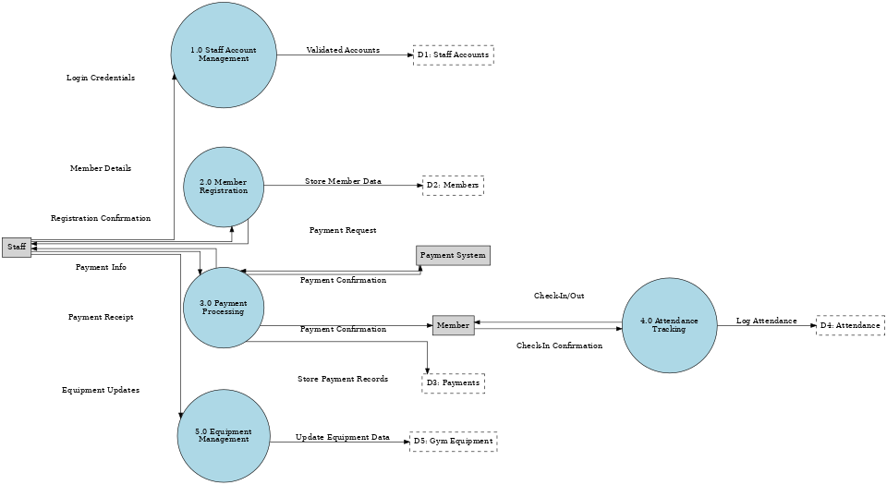**DFD – Context Diagram (Level 1)**

**Figure 16. Data Flow Diagram (Level 1)**

**External Entities (Data Sources/Destinations)**

This section outlines the external entities that interact with the Gym Management System, serving as either sources or recipients of data. These entities operate outside the system boundary but play a crucial role in initiating and receiving system processes. Key external actors include staff, who provide login credentials, register new members, and verify check-ins; members, who supply personal information and interact during check-in procedures; and the payment system, which is responsible for validating financial transactions. Recognizing these entities helps define the system’s scope and ensures that all external interactions are accurately captured during analysis and design.

* **Staff** (provides login credentials, registers members, checks in members)
* **Member** (provides personal details, interacts during check-in)
* **Payment System** (verifies payments)

**Data Flows**

This section describes the movement of data between external entities and the Gym Management System, capturing the key interactions that support the system’s functionality. Data flows illustrate how information such as login credentials, member details, check-in requests, and payment confirmations are transmitted to and from the system. For example, staff send member details and payment confirmations to the system, while members initiate check-in requests.

* Staff → Login Credentials → Gym Management System
* Staff → Member Details + Payment Confirmation → Gym Management System
* Member → Check-In Request → Gym Management System
* Gym Management System → Confirmation/Receipts → Staff & Member
* Gym Management System ↔ Payment System (Payment Validation)

**SECURITY DESIGN**

The security of the Gym Management System is paramount to protect sensitive information such as staff credentials, member personal data, financial transactions, and attendance records. The system is designed to ensure confidentiality, integrity, and availability of data while preventing unauthorized access or malicious activity.

Key considerations include safeguarding user credentials through strong cryptographic measures, enforcing access control at multiple levels, protecting data in transit and at rest, and ensuring that system activities are auditable. Additionally, security policies comply with applicable data privacy laws and industry best practices to maintain member trust and operational reliability.

**Authentication and Authorization Mechanisms**

This section describes the security measures implemented to control access to the Gym Management System through authentication and authorization processes. Authentication ensures that users—such as staff and administrators—are correctly identified by verifying credentials like usernames and passwords during login. Once authenticated, authorization mechanisms determine the level of access each user has based on predefined roles and permissions, restricting or allowing access to specific features and data within the system. These layered security protocols are essential for protecting sensitive member information, preventing unauthorized access, and maintaining the integrity and confidentiality of the system’s operations.

**Password Hashing**

Passwords are never stored or transmitted in plaintext. The system uses the BCrypt hashing algorithm to securely hash passwords. BCrypt provides a strong defense by incorporating salting and multiple hash rounds, thereby mitigating risks from brute force and rainbow table attacks.

**Two-Factor Authentication (2FA)**

Upon successful username and password verification, the system requires staff users to authenticate via two-factor mechanisms. This is implemented using security questions stored securely with hashed answers in the database. This additional verification step significantly reduces unauthorized login risks even if credentials are compromised.

**Role-Based Access Control (RBAC)**

Features and data access within the system are restricted based on user roles and account states. Roles such as administrator, staff, or manager have predefined permissions controlling what data can be viewed or modified. Suspended or inactive accounts are prevented from logging in, ensuring that only authorized personnel perform critical operations.

**Session Management**

The system tracks user sessions with timeouts to prevent unauthorized reuse. Sessions expire automatically after periods of inactivity. Forced logouts occur after concurrent session detection or upon user request for enhanced security. This mechanism reduces risks of session hijacking or persistent unauthorized access.

**Data Encryption and Protection Measures**

The Gym Management System integrates essential data encryption and security mechanisms to safeguard sensitive information such as staff credentials, member records, and payment details. Passwords and security answers are stored using hashing techniques, ensuring they cannot be easily reversed or exposed. Data transmitted between system modules and external entities is protected through encryption protocols, preventing unauthorized interception. Access controls and status flags further restrict system usage to verified staff and active members, minimizing risks of data breaches. These measures collectively ensure confidentiality, integrity, and reliability of the system’s data.

**Data Storage Protection**

Sensitive data such as passwords and answers to security questions are stored only as cryptographic hashes with strong salting. Other personal or financial member data is protected by restricting database access rights and enforcing strict input validation.

**Secure Database Connections**

Although the system typically runs in a trusted local network environment, SSL/TLS encryption is configured for MySQL connections when the database server is remotely accessed. This prevents interception and tampering of data during transfer.

**Application Configuration Security**

Configuration files containing database connection strings and any sensitive secrets are secured with strong encryption or restricted file permissions on the host system. This prevents potential leakage of database credentials or internal system parameters.

**Audit Trails and Logging**

All critical security events—including login attempts, password changes, payment transactions, and record modifications—are logged with timestamps and user identifiers. Logs support forensic investigations and compliance audits.

**Regular Updates and Patch Management**

The application and its environment receive periodic updates to mitigate emergent vulnerabilities. Database systems, development frameworks, and operating systems are kept current, reducing exposure to known flaws.

**PERFORMANCE DESIGN**

This section outlines the strategies and considerations incorporated to ensure the Gym Management System performs efficiently under expected workloads. Performance design focuses on optimizing system responsiveness, scalability, and resource utilization to provide a smooth user experience during peak usage times. Key elements include efficient database queries, minimal server response times, and optimized front-end components to reduce load times.

**Performance Requirements and Objectives**

* Ensuring that typical user-initiated actions such as member search, equipment lookup, and data loading complete within 5 seconds to guarantee smooth workflows.
* Achieving dashboard refresh times that are consistently under 3 seconds, allowing administrators to promptly visualize up-to-date gym statistics without delay.
* Supporting concurrent access by multiple staff users, maintaining system responsiveness without notable lag or slowdown during peak operational hours.
* Handling high-frequency transaction processing for attendance check-ins
* These objectives align with user expectations for immediate feedback and system reliability in a business-critical environment.

**Strategies for Optimizing System Performance**

To meet these objectives, several optimization strategies are employed at multiple layers of the application:

**Database Indexing**

Strategically indexing frequently searched columns such as usernames, member IDs, equipment names, and attendance timestamps accelerates query execution times. Composite indexes support multi-attribute search scenarios, reducing full table scans.

**Connection Pooling with ADO.NET**

The system leverages ADO.NET connection pooling to minimize the overhead of establishing and closing database connections repeatedly. By reusing active connections efficiently, the application conserves resources and improves responsiveness during bursts of database activity.

**Caching Frequently Accessed Data on Client Side**

Static or seldom-changing data such as gym equipment lists or membership plans are cached locally in memory during user sessions. This reduces redundant database queries, decreasing network traffic and speeding up UI rendering.

**Pagination and Lazy Loading in List Views**

Large data sets (like member or equipment lists) are loaded incrementally using pagination or virtualized scrolling. Items are fetched on-demand as the user navigates, limiting memory use and initial load time, especially within DataGridViews or ListViews.

**Deferred Control Initialization**

UI controls within forms (such as tabs or complex lists) are loaded only when first accessed rather than upfront. This reduces initial form load time and distributes processing load across the user session, enhancing perceived performance.

**Bulk Operations and BeginUpdate/EndUpdate Methods**

When populating list controls, batch operations combined with methods like BeginUpdate and EndUpdate (to suspend repainting during large data changes) minimize UI flicker and improve load speed.

**Efficient Resource Management:**

Reducing unnecessary object creations and disposing of disposable resources promptly avoids memory bloat and promotes efficient garbage collection, which is monitored via profiling tools.

**Performance Testing Plan**

An ongoing and rigorous performance testing regimen is implemented to validate the system against design goals:

**Simulated Multi-User Load Tests**

Simulations emulate multiple concurrent users performing typical workloads (search, update, payment entry) to measure system throughput and response times under realistic conditions.

**Stress Testing Payment and Attendance Modules**

Special attention is paid to high-impact modules. Stress tests generate bursts of transactions to assess transactional integrity, error handling, and latency under heavy system load.

**Query Response Benchmarking**

Pre- and post-optimization benchmarking of critical SQL queries (e.g., member searches, dashboard aggregates) identifies bottlenecks and verifies the effectiveness of indexing and query optimizations.

**UI Responsiveness Monitoring**

Tests measure frame rendering and input latency in key UI components to ensure smooth user interactions.

**ERROR HANDLING AND LOGGING**

This section details the mechanisms implemented to manage system errors and maintain reliable logs within the Gym Management System. Error handling ensures that unexpected system behaviors, user input issues, and operational failures are gracefully managed through clear notifications and fallback procedures, minimizing disruptions to users. Logging mechanisms are integrated to capture detailed information about system events, errors, and user activities, supporting debugging, monitoring, and security auditing.

**Error Handling Mechanisms and Strategies**

Effective error handling is crucial for maintaining system reliability, preventing data corruption, and providing users with meaningful feedback during exceptional conditions. The Gym Management System incorporates structured exception management implemented comprehensively in Visual Basic 2010 using Try-Catch-Finally blocks around all critical operations, particularly database interactions.

* **Try-Catch Blocks:** All database commands (queries, inserts, updates, deletes) are enclosed within try-catch blocks. This ensures that any unexpected failures (such as connection issues or SQL errors) are gracefully caught, preventing application crashes or data inconsistency.
* **Validation Checks:** Before any data is sent to the database, the UI performs thorough validation checks on user input (e.g., required fields filled, data types correct, logical constraints met). This preemptive validation reduces the probability of triggering database exceptions.
* **User-Friendly Error Dialogs:** When exceptions occur, the system displays clear, non-technical error messages to users, helping them understand what went wrong and how to correct it. Technical details are logged internally without overwhelming the user.
* **Finally Blocks for Cleanup:** Resources such as database connections, commands, and data readers are always released in the Finally clause to avoid resource leaks, ensuring system stability during high load.
* **Global Exception Handler:** The application defines a centralized handler for uncaught exceptions, which logs errors and presents a generic error message guaranteeing consistent user experience even outside localized try-catch scopes.

**Logging Requirements and Specifications**

Logging captures essential information to support audits, troubleshooting, and compliance:

* **What is Logged:** All login attempts (successful and failed), payment transactions, data changes (member updates, equipment modifications), and exceptions are logged with contextual metadata including timestamp, user ID, module name, and error stack trace.
* **Log Storage:** Logs are stored locally on the host machine in secured, append-only text files with daily rotation to manage size. Backup policies ensure logs are archived regularly to prevent loss.
* **Log Format:** Each entry contains standardized fields such as Date-Time, User, Action/Exception Type, Detailed Message, and Severity Level, supporting easy parsing and analysis
* **Alerting:** Critical errors such as repeated authentication failures, data write errors, or payment processing issues can trigger alerts to administrators for prompt resolution.

**Error Codes and Messages**

|  |  |  |
| --- | --- | --- |
| **Error Code** | **Description** | **User Message** |
| 1001 | Invalid login credentials | "Incorrect username or password." |
| 1002 | Account locked | "Your account has been locked. Contact admin." |
| 2001 | Database connection failure | "Unable to reach the database; please try again later." |
| 3001 | Data validation error | "Please check your input; some fields are invalid." |
| 4001 | Payment processing failed | "Payment failed; please verify your payment information." |

The system standardizes error handling through predefined error codes mapped to descriptive messages. This approach simplifies localization and maintenance:

**Table 1.** Error Codes and Messages

**THIRD-PARTY INTEGRATIONS**

This section describes the integration of external services and platforms that extend the functionality of the Gym Management System. Third-party integrations are implemented to streamline operations, enhance user experience, and reduce development overhead. Key integrations may include payment gateways for secure transaction processing, email or SMS services for automated notifications, and analytics tools for monitoring system usage and performance.

**List of Third-Party Services or APIs Integrated into the System**

Currently, the Gym Management System operates as a standalone VB.NET desktop application without integration of any third-party APIs or external services. All core functionalities—including user authentication, member management, payment tracking, and reporting—are handled internally within the application. While this approach simplifies deployment and minimizes external dependencies, it also limits scalability and access to advanced features such as online payment processing, automated notifications, or real-time analytics. Future enhancements may consider integrating reliable third-party services to improve functionality, efficiency, and user experience, provided they align with security, performance, and maintainability requirements.

**Description of Integration Points and Data Exchange Formats**

Potential future enhancements may include integration with external services such as various third-party APIs and platforms to expand system capabilities, improve user experience, streamline operational workflows, and enhance communication and payment processing functionalities:

* **SMS or Email Gateways:** For sending two-factor authentication codes, password reset tokens, or membership renewal notifications. Data exchanged could use JSON or XML payloads conforming to gateway provider standards.
* **Online Payment Gateways:** To accept electronic payments from members. Integration would involve secure RESTful API calls with encrypted payloads, supporting JSON-formatted requests and responses.

**DEPLOYMENT PLAN**

This section outlines the strategy and steps for deploying the Gym Management System into its target environment. It covers preparation activities, installation procedures, configuration settings, and post-deployment verification to ensure a smooth transition from development to production. The plan defines the hardware and software requirements, user training schedules, and backup protocols to minimize downtime and data loss.

**Overview of the Deployment Process**

* XAMPP Installation: Set up XAMPP on a dedicated or shared server machine within the gym’s network. MySQL service is configured with secure user accounts and password policies.
* MySQL Database Configuration: Deploy the initial database schema, create required users, and configure backups and performance optimization settings.
* Application Deployment: Distribute the Visual Basic 2010 Windows Forms application to staff PCs via executable installers or managed software deployment tools. Configure each installation with database connection strings securely stored in encrypted configuration files.
* Testing: Conduct thorough system integration and user acceptance testing in the production environment to ensure stability and performance correctness.

**Hardware and Software Requirements for Deployment**

**Client Systems:**

* OS: Windows 10
* .NET Framework: 4.x or later
* RAM: Minimum 4GB
* CPU: Dual-core or better

**Server System:**

* OS: Windows or Linux compatible with XAMPP
* RAM: 8GB minimum, scalable based on user load
* Storage: SSD recommended, with redundant backup

**Configuration Management and Version Control Procedures**

* **Source Control:** Codebase is managed using Git with standard branching and merging workflows ensuring version traceability and collaborative development.
* **Environment Configuration:** Environment-specific settings such as database URLs and credentials are stored in external, encrypted configuration files separate from source control to prevent sensitive information leakage.
* **Release Management:** Software releases are versioned semantically and deployed through tested installers. Rollback plans are in place to revert to previous stable versions if issues arise post-deployment**.**

**MAINTENANCE AND SUPPORT**

This section defines the processes and resources dedicated to the ongoing maintenance and support of the Gym Management System following deployment. It outlines scheduled activities such as software updates, bug fixes, performance optimizations, and security patches to ensure the system remains reliable and efficient over time.

**Guidelines for System Maintenance and Support**

* Schedule regular backups of the MySQL database using XAMPP tools or native MySQL backup utilities; verify backup integrity frequently.
* Perform database optimization tasks such as rebuilding indexes, cleaning logs, and purging obsolete records on a scheduled basis to maintain performance.
* Monitor system logs continuously for unusual activity or recurring errors, establishing thresholds for alerting technical staff.
* Provide comprehensive user training and reference documentation to staff to reduce operational errors and improve issue reporting.

**Procedures for Handling Software Updates, Patches, and Bug Fixes**

* Perform updates and patches in a staging environment prior to production deployment to avoid service interruptions
* Conduct regression testing to ensure new changes do not introduce errors.
* Follow semantic versioning practices with detailed release notes describing fixes and new features for transparency.
* Apply emergency patches promptly when security vulnerabilities are discovered.

**Escalation Process for Resolving Issues**

* Tier 1 Support: Frontline personnel handle routine queries, user errors, and software usage questions.
* Tier 2 Support: Technical specialists address system defects, data issues, and configuration problems requiring deeper system knowledge.
* Tier 3 Support: Development team tackles complex bugs, architectural changes, and security incidents requiring code fixes or enhancements.
* Critical issues are escalated immediately through formal protocols, ensuring swift resolution to maintain system availability and data integrity.

**REVISION HISTORY**

This section documents all changes made to the Gym Management System’s design, requirements, and documentation throughout the project lifecycle. Each revision entry includes a unique version number, the date of the change, the author or team responsible, and a brief description of the modifications.

|  |  |  |  |
| --- | --- | --- | --- |
| **Date** | **Version** | **Description** | **Author** |
| 2025-08-26 | 1.0 | Initial Document Creation | Revilla, James Andrei N. |

**Table 2**. Revision History